Today we have implemented an inverter with bipolar NPN Transistor. If the VIN of the circuit is LOW, then the OUT is high and if the VIN is HIGH, then the output is LOW.

We start with just 2 rezistors of 1kOhm each and an Transistor, and we try to invert the DC signal that is recived from VCC but the operation takes too long so we lose half of state.

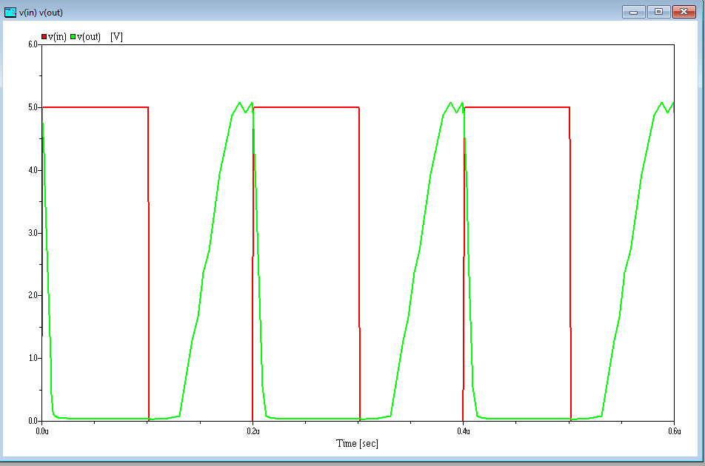

So in order to fix this we add 2 capacitors, first capacitor c1 so we can hold current longer so that we don’t love half of state and the second one is used to filter out the spikes that might appaer. First capacitor C1 has a capacitance of 1 pF and the second capacitor C2 can have a capacitance of 15 pF but with that number it’s still slow so we use a capacitor of 45F and we can see that our invertor now acts faster.

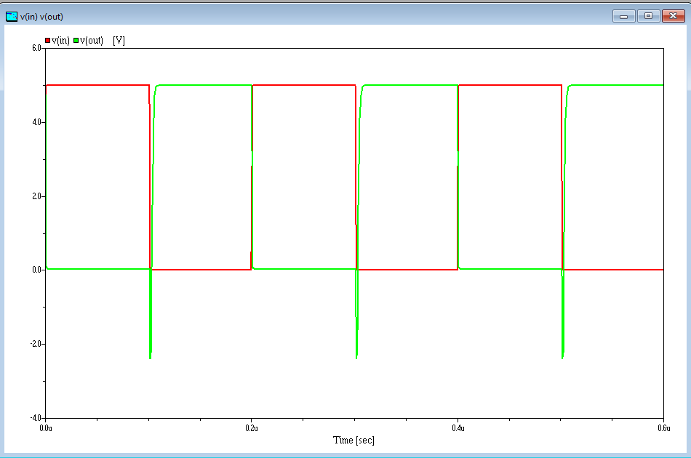

Code :

